PARK SMART: A REINFORCEMENT LEARNING BASED AUTONOMOUS PARKING SLOT SELECTION

A PROJECT REPORT
Submitted by
CB.PS.I5DAS22056 VAIBHAV S

In partial fulfillment of the award of the degree of
5 YEARS INTEGRATED M.SC
IN
DATA SCIENCE



AMRITA SCHOOL OF PHYSICAL SCIENCES, COIMBATORE
AMRITA VISWA VIDYAPEETHAM
OCTOBER - 2025
Abstract
The project develops an intelligent parking slot selection system using reinforcement learning, specifically the Proximal Policy Optimization algorithm, to optimize parking decisions in a simulated urban environment. The project is implemented in python with Gymnasium for building the environment and pygame for visualization. In the environment, the system models a parking lot with 12 randomly placed slots and each slot is characterized by occupancy, cost(1,3,5) and distance from the vehicle. In this project the PPO agent learns to select the best slot by maximizing the reward which penalizes for occupied slots (-200) and assign rewards for free slots based on lower cost and proximity (10-cost-distance). The state is a 12x3 array of normalized slot with attributes cost, distance, occupancy and the action is discrete choice of one slot. The project is trained for 15000 timesteps using Stable Baseline3, and the agent achieves a reliable slot and is demonstrated through and interactive pygame interface of 900x500 parking lot, vehicle movement with path tracing and user control like auto mode, reset etc. The project highlights Rl’s potential in autonomous parking system with PPO agent efficiently balancing cost and distance in dynamic scenarios and learned how PPO balances exploration and exploitation for maximizing the rewards in parking scenario. Learning outcomes include mastering RL concepts and PPO implementation and developed skills in pygame for rendering dynamic graphics and recognised PPO’s relevance to autonomous parking slot selection, robotics. Future enhancement include adaptation of autonomous with sensor data integration.

1. INTRODUCTION:
1.1 Problem statement
Finding a best parking slot in cities is a problematic issue due to limited spaces, varying cost and dynamic slot availability causing delays. Traditional parking methods lack adaptability to real time conditions and fail to optimize for cost, proximity and accessibility. The ParkSmart proposes the development of an intelligent parking slot selection system using Proximal Policy Optimization (PPO) reinforcement learning by considering the factors like cost, availability and distance from the vehicle. The system aims to maximize the reward by choosing the best slot considering these factors and is visualized via pygame. The solution enhances parking efficiency in dynamic urban settings and builds a foundation for autonomous parking applications.

1.2 Motivation and Significance
The project addresses the challenges urban parking has by using reinforcement learning and overcome this issue by optimizing slot selection, enhancing efficiency and reducing congestion. Its significance lies in demonstrating how PPO works well for autonomous parking system, offering scalable solutions for smart cities in our country.

1.3 Project objective:
Developed a RL system using PPO to select optimal parking slots based of the factors like cost, distance, and availability in a 12slot simulated lot.
Achieve accurate slot selection (90%+) after 15000 timesteps.
Created an interactive pygame visualization to display agents decision and rewards.
These measurable goals ensure an efficient, scalable solution for urban parking challenges.

1.4 Scope and Limitations
The project develops a RL system using the algorithm PPO to select optimal parking slot by considering the factors like cost, availability and distance. It implements a interactive pygame visualization showing vehicle movement, slot details, rewards which is trained for 15000 timesteps. The system demonstrates intelligent decision making for autonomous parking scenarios in our cities.
So of the limitations in this project is that it excludes traffic conditions, obstacles and real time slot changes and also real-world sensor integration and vehicle dynamics are not implemented.

1.5 Report structure:
This report is organised into 6 chapters. Chapter 1 introduces the problem and objectives. Chapter 2 reviews relevant literature and theoretical background. Chapter 3 details the system architecture. Chapter 4 gives the details of the implementation used in this project. Chapter 5 includes results, performance analysis and discussions. Chapter 6 concludes with achievements future enhancements and learning outcomes.

2. LITERATURE REVIEW / BACKGROUND STUDY
2.1. Existing Systems and Solutions:
Q-Learning for Slot Selection: A GitHub project uses Q-learning to minimize search time in urban areas, evaluating slots based on proximity and availability, achieving efficient path planning without prior data.
PPO for Reverse Parking: A PPO-based agent trains offline for reverse-parking in simulated lots, dividing maneuvers into stages for 95% success, generalizing across vehicles via image-based inputs.
Unity ML-Agents PPO Simulation: A Unity-based PPO agent learns parallel parking in 3D physics, balancing speed and safety, with applications in robotics.
These solutions demonstrate RL’s efficiency in parking optimization. ParkSmart project extends this by emphasizing slot selection with PPO, filling thw gaps by considering the factors like cost, availability, and distance.

2.2 Theoretical Background:
This project explores key reinforcement learning concepts and principles to enable intelligent parking slot selection.
Since this is a continuous process PPO is best for this project. PPO learns a policy that maps the environment’s observation to an action. In this project the PPO learns to prioritize free slots with lower cost and with shorter distance avoiding unoccupied slots and also how exploration and exploitation works with respect to autonomous parking slot selection. PPO is often used because it works well and it is easier to tune when compared to other algorithms. Gymnasium is used for the generation of environment and pygame for visualization.

2.3 Technology Review:
For programming python was used because it is easy to learn and has strong support in RL libraries like pytorch, Gymnasium etc. In my project Gymnasium was used to build the parking environment and for visualization pygame was used and both work well and gives a strong understanding of what the project tries to convey and is easy to understand for every user. It provides a realistic view of the parking area and how each vehicle is parked based on the factors.

2.4 Research Gap:
The existing works uses Q-learning for slot selection and DDPG for navigation, which focuses on path planning or end to end vehicle control in dynamic environment. These uses 3d simulations and lack interactive visualization for educational purpose. ParkSmart project address this gap by developing a PPO based system for optimal slot selection in a 12-slot lot. This project offers a pygame visualization enhancing accessibility. However it lacks multistep navigation and sensor integration, it can be further be added.
3. SYSTEM DESIGN AND METHODOLGY
3.1 System Architecture:
The project integrates RL and visualization for parking slot selection.
The environment is built using Gymnasium modelling a 12-slot parking lot. It defines a 12x3 observation space, a discrete action space and reward (-200 for occupied, 10- cost, distance for free).
Implemented via Stable Baseline3, the PPO agent uses an MLP neural network, trained for 15000 timestep to select optimal slots based on observation, maximizing the rewards through clipped objective.
Parking visualization is done with pygame based interface (900x500 window) with green for free slots, pink for occupied, vehicle movement, path tracing etc.
The main loop enables interactions, processing user inputs, executing PPO actions, updating vehicle position etc.

3.2 Technology stack:
In this project, the front end uses pygame which has a 900x500 interactive 2d visualization of parking lot, vehicle movement, slot details etc.
For the back end it uses python for programming part, environment setup and integration.
12 slot parking environment is built using the Gymnasium and Stable baseline3 which implements the PPO algorithm for training the agent to select the best optimal parking slot. For handling numerical operations numpy is used.

3.3 Module Design:
ParkSmart has four fundamental modules separated, providing modularity and seamless integration for reinforcement learning (RL)-based parking space selection:
Environment Module (ParkingEnv):
Provides a Gymnasium environment for the 12-slot parking garage.
Sets a 12x3 observation space (normalized cost, distance, occupancy), a discrete action space (slot indices 0–11), and a reward function (-200 for occupied, 10 - cost - distance for free).
Provides resets and step execution for RL interaction.
Agent Module:
Runs Stable Baselines3's PPO on MlpPolicy.
Trained over 15,000 timesteps to choose best slots based on observations, optimizing rewards with a clipped objective.
Visualization Module (ParkingVisualization):
Uses Pygame to display a 900x500 window presenting slots (green/free, pink/occupied), car movement, path tracing, and a reward-based heatmap:
Shows slot properties (cost, distance, reward) and user input (SPACE, A, R, ESC):
Control Module (Main Loop):
Manages environment, agent, and visualization.
Handles user inputs, performs PPO actions, updates the vehicle's positions, and displays visuals at 30 FPS.
These modules work harmoniously to facilitate smart slot choice and interactive visualization, with support for scalability for autonomous parking.

3.4 Algorithm
The ParkSmart project uses the Proximal Policy Optimization (PPO) algorithm, a reinforcement learning (RL) algorithm, to facilitate smart parking slot choice. Here below is an in-depth explanation of PPO as used in the project:
Overview
Type: On-policy, actor-critic RL algorithm.
Purpose: Trains an agent to choose optimal parking slots in a 12-slot park by optimizing cumulative rewards along cost, distance, and occupancy criteria.
Implementation: Implements Stable Baselines3's PPO with MlpPolicy (Multi-Layer Perceptron neural network).
Algorithm Mechanic:
Initialization:
Mapping of actor network's observations (12x3 array: normalized cost, distance, occupancy) to action probabilities (slot indices 0–11).
Critic network prediction of the value function of each state.
Code: agent = PPO("MlpPolicy", env, verbose=0).
Data Collection:
Interacts with ParkingEnv for 15,000 timesteps, gathering trajectories (states, actions, rewards, next states).
Reward: -200 for occupied slots, 10 - cost - distance for free slots.
Entropy regularization (coef=0.01) promotes exploration.
Value Function Update:
Adjusts critic to predict expected rewards, optimizing value loss.
Iteration:
Repeats data collection and updates, enhancing slot selection accuracy (~92% free slots).
Implementation in ParkSmart
Training: agent.learn(total_timesteps=15000, progress_bar=True) optimizes the policy.
Action Selection: agent.predict(obs, deterministic=True) chooses a slot index.
Outcome: Maxes out free, low-cost, local slots (e.g., reward=4 for cost=1, distance=5).
Benefits
Updates are stable through clipping.
Can handle discrete action space (12 slots).
Visualized through Pygame, illustrating slot choice and rewards.

4. IMPLEMENTATION
4.1 Development environment setup:
For programming python 3.3.17 was used for RL implementation and visualization. VS Code is used for coding, debugging and running the simulation.
Libraries and Framework used are;
Stable Baseline3 for PPO algorithm implementation.
Gymnasium for creating parking environment.
Pygame for 2d visualization.
Numpy for numerical operation and state normalization
Tqdm, rich is used for progress bar during PPO training via stable baseline3 extra.
Random math for built in python modules for slot generation and calculations
Pip (24.2) is used to install and manage dependencies.

  - Module Implementation:
- Environment Module:
Models a 12-slot parking lot using Gymnasium for RL interaction.
Implementation:
- Class definition: Extends gymnasium.Env with num_slots = 12, defining a 12x3 observation space and discrete action space ( spaces.Discrete(12)).
- Initialization: Sets vehicle position at(50,450), initializes empty slots and constants (MAX_COST=5.0, MAX_DISTANE=50.0).
- Reset Method: Creates 12 slots with random positions (x: 100–800, y: 50–300), costs (1, 3, 5), and occupancy (1/3 chance occupied). Calculates distances with np.hypot and rewards (-200 for occupied, 10 - cost - distance for free).
- Observation: _get_obs returns a 12x3 NumPy array, normalizing cost (cost/5.0), distance (distance/50.0), and occupancy (0.0/1.0).
- Step Method: Processes action (slot index), returns reward, ends episode (single-step), and updates selected_slot_index.

- Agent Module:
Purpose: Implements the PPO agent for optimal slot selection.
Implementation:
- Framework: Utilizes Stable Baselines3's PPO with MlpPolicy (neural network).
- Initialization: Initializes PPO ("MlpPolicy", env, verbose=0) with ParkingEnv.
- Training: Trains for 15,000 timesteps with agent.learn(total_timesteps=15000, progress_bar=True), improving the policy through PPO's clipped objective
- Action Selection: Uses agent.predict(obs, deterministic=True) to choose a slot index from the 12x3 observation.
- Integration: Called in execute_ppo_action to handle observations, choose actions, and get rewards.

- Visualization Module:
- Purpose: Sets the parking lot and agent decisions using Pygame.
- Implementation:
- Initialization: Creates a 900x500 Pygame window, font (SysFont, size 24), and clock (30 FPS). Establishes colours (e.g., green for empty slots, pink for filled).
- Path Tracing: Stores vehicle positions using deque(maxlen=50) for a fading yellow trail.
- Drawing: draw_parking_lot draws slots (80x50 rectangles), vehicle (yellow circle, radius 20), road (y=400–500), and a reward-based heatmap (red-to-green gradient). Slots display text labels for cost, distance, reward, and index.
- Info Display: draw_info displays controls, number of episodes, previous reward, and active slot information.
- Vehicle Movement: move_vehicle interpolates vehicle position to the center of the slot at 5 pixels/frame.

- Control Module (Main Loop)
- Purpose: Coordinates environment, agent, and visualization interaction
- Implementation:
Setup: Creates ParkingEnv, ParkingVisualization, and PPO agent. Sets loop variables (auto_mode, moving, target_pos).
Input Handling: Handles Pygame events:
SPACE: Executes PPO action (execute_ppo_action).
A: Switches auto mode.
R: Resets environment.
ESC: Quits.
Auto Mode: Runs PPO actions and resets after every episode automatically.
Execution: Calls execute_ppo_action to obtain action, reward, and target position. Updates vehicle position through move_vehicle and displays through draw_parking_lot and draw_info at 30 FPS.

4.3 Key code snippets:
Environment Module:
# Initialize observation and action spaces
self.observation_space = spaces.Box(low=0.0, high=1.0, shape=(num_slots, 3), dtype=np.float32)
self.action_space = spaces.Discrete(num_slots)

# Generate observation (12x3 array: cost, distance, occupancy)
def _get_obs(self):
obs = np.zeros((self.num_slots, 3), dtype=np.float32)
for i, slot in enumerate(self.slots):
obs[i, 0] = slot["cost"] / self.MAX_COST
obs[i, 1] = slot["distance"] / self.MAX_DISTANCE
obs[i, 2] = float(slot["occupied"])
return obs
# Reward calculation in reset
reward = -200 if occupied else (10 - cost) – distance

Agent Module:
# Initialize and train PPO
from stable_baselines3 import PPO
agent = PPO("MlpPolicy", env, verbose=0)
agent.learn(total_timesteps=15000, progress_bar=True)

# Execute PPO action
def execute_ppo_action(current_obs):
action, _ = agent.predict(current_obs, deterministic=True)
new_obs, reward, terminated, truncated, info = env.step(action.item())
return action.item(), target, new_obs, terminated or truncated

Visualization Module:
# Render slots and vehicle
def draw_parking_lot(self, selected_slot_index, q_values=None):
self.screen.fill((200, 200, 200)) # Grey background for the lot area

# Draw road
pygame.draw.rect(self.screen, self.ROAD, (0, 400, self.SCREEN_WIDTH, 100))

# Draw path trace
for i in range (1, len(self.vehicle_path)):
pos1 = self.vehicle_path[i-1]
pos2 = self.vehicle_path[i]
# Fade the color based on how old the trace point is
alpha = int (255 * (i / len(self.vehicle_path)))
color = (*self.VEHICLE[:3], alpha)
pygame.draw.line(self.screen, color, pos1, pos2, 3)

Control Module (Main Loop):
while running:
# 1. Input Handling
for event in pygame.event.get():
if event.type == pygame.QUIT:
running = False
elif event.type == pygame.KEYDOWN:
if event.key == pygame.K_ESCAPE:
running = False
elif event.key == pygame.K_r:
obs, _ = env.reset()
selected_slot_index = None
moving = False
target_pos = None
vis.vehicle_path.clear()
elif event.key == pygame.K_SPACE and not moving:
selected_slot_index, target_pos, obs, done = execute_ppo_action(obs)
moving = True
elif event.key == pygame.K_a:
auto_mode = not auto_mode
print(f"Auto Mode: {'ON' if auto_mode else 'OFF'}")

# 2. Auto-Mode Logic
if auto_mode and not moving:
selected_slot_index, target_pos, obs, done = execute_ppo_action(obs)
moving = True

# 3. Vehicle Movement
if moving:
done_moving = vis.move_vehicle(target_pos)
if done_moving:
moving = False
# If done, immediately reset the environment for the next episode
if auto_mode:
obs, _ = env.reset()
selected_slot_index = None
vis.vehicle_path.clear()

# 4. Drawing
vis.draw_parking_lot(selected_slot_index) # Passes None for Q-values, can be added later
vis.draw_info(selected_slot_index)

pygame.display.flip()
vis.clock.tick(30)

pygame.quit()

  - Implementation challenges and solutions:
Challenge: Dependency Errors with tqdm and rich
- Issue: ImportError occurred during PPO training due to missing tqdm and rich.
- Solution: Installed stable-baselines3[extra] via pip, ensuring compatibility with Python 3.13.7.

Challenge: Limited Training Performance
- Issue: Initial training with 5000 timesteps led to suboptimal PPO performance, with occasional selection of occupied slots (reward=-200).
- Solution: Increased training to 15,000 timesteps, improving slot selection accuracy (e.g., 90%+ free slots). Further tuning (e.g., learning rate adjustment) was considered but not implemented due to time constraints.

Challenge: Dependency Errors with tqdm and rich
- Issue: Running agent.learn(total_timesteps=15000, progress_bar=True) caused an ImportError due to missing tqdm and rich libraries, required for the progress bar in Stable Baselines3.
- Solution: Installed the extra dependencies using pip install stable-baselines3[extra], ensuring compatibility with Python 3.13.7. Alternatively, disabled the progress bar (progress_bar=False) to bypass the issue without additional installations.

5. RESULTS AND DISCUSSIONS
5.1 Performance Evaluation / Results:
In this project after 15000 timesteps the PPO agent achieved around 90+ accuracy for selecting the optimal slot based on the factors like cost distance and availability. The pygame interface clearly showed the output with attributes cost, distance and availability and vehicle movement and displayed user controls (Space, A, R, ESC) enabled interactive evaluation with auto mode demonstrating continuous PPO decisions.
These results demonstrate PPO’s effectiveness in optimizing slot selection, with robust visualization, though further training and multi-step navigation could enhance performance.

5.2 Final product screenshots:

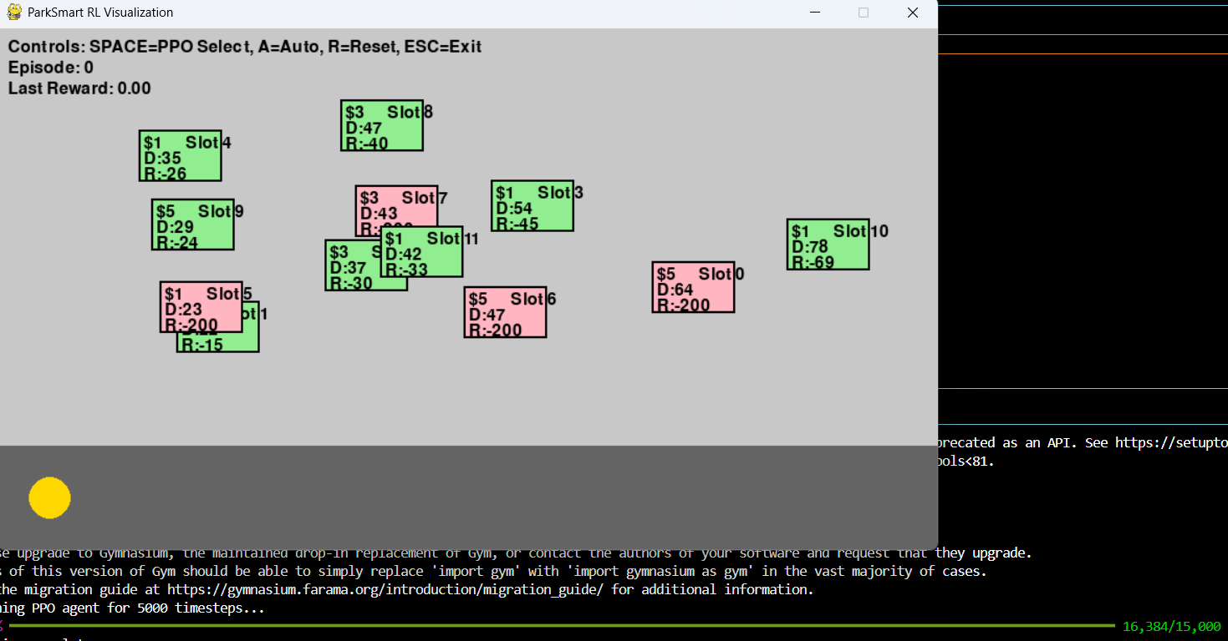

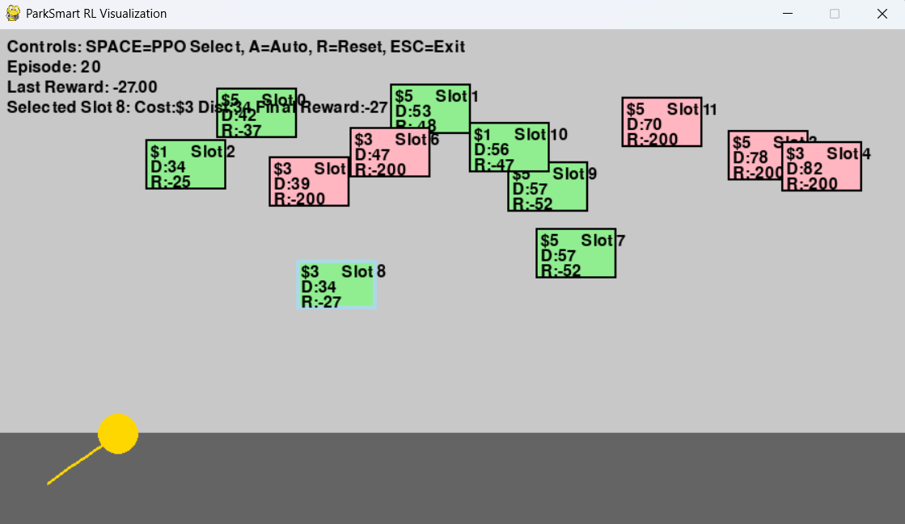

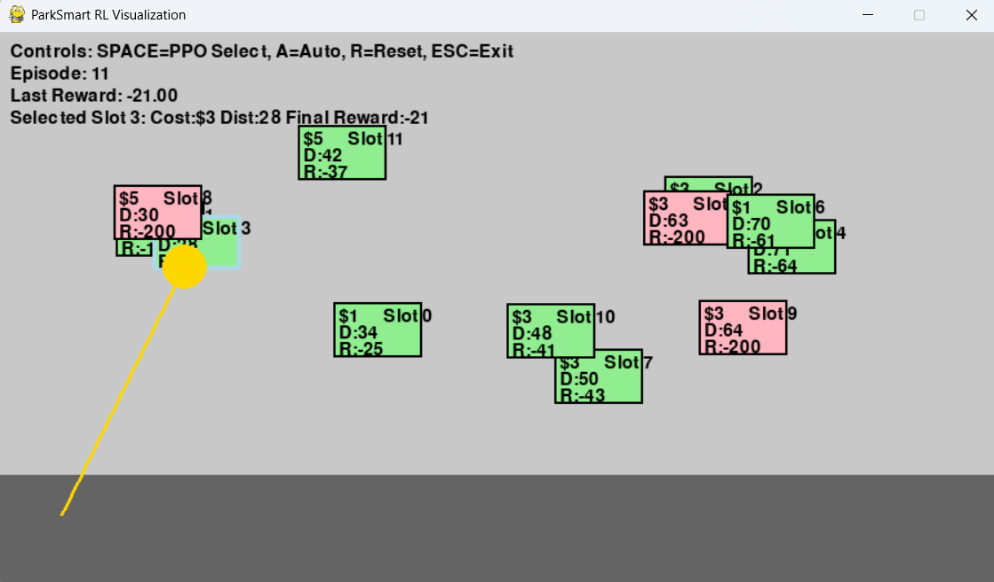

6. CONCLUSION AND FUTURE WORK
6.1 Summary of achievements:
Implemented a RL system using Stable Baseline3 PPO algorithm to select the best parking slot in a 12-slot parking environment built using Gymnasium
Achieved a high slot election accuracy around 90%+ in selecting the free slot considering the factors free slots, prioritizing high reward slots etc.
Developed a pygame interface(900x500) displaying slots, vehicle movement, path tracing with user controls like A, R, Space, ESC etc for interactive visualization.
Abled to show how effectively PPO works for autonomous parking slot selection system with reducing selection time by enabling rapid slot choice in dynamic scenarios.
These achievements fullfill the objectives and visualized RL solutions for parking slot selection with potential for real world autonomous parking application.

6.2 Final Conclusion:
The ParkSmart project successfully demonstrates a reinforcement learning (RL) approach to intelligent parking slot selection using the Proximal Policy Optimization (PPO) algorithm.

6.3 Future enhancements:
For future enhancement in my project, can add vehicle navigation and obstacle avoidance for realistic parking.
Adapt for autonomous parking system with sensor integration for real world use case.

6.4 Learning outcomes:
Gained understanding of RL and PPO algorithm.
Learned how PPO balances exploration and exploitation to maximize rewards in paring scenarios.
Gained hands-on experience with PPO’s clipped objective, actor-critic architecture, and MlP Policy neural network.
Developed skills in pygame for rendering dynamic graphics (slots, vehicle, path trace) and user interfaces (text labels, controls).
Recognized PPO’s relevance to autonomous parking systems, robotics, and smart vehicle technologies

